**CASE STUDY FOR DATABASE DESIGN**

**AND RELATIONSHIP UNDERSTANDING**

______________________________________________________________________________

**Requirement:**

You need you design a database to store Retail Data for a Sales Business.

The Entities are :

**1. Product**

**2. Customers**

**3. Time**

**4. Sales**

**Relation Rule 1: Every Sale should happen for a valid (available) product only**

**Relation Rule 2: Every Sale should happen for a valid (registered) customer only**

**Relation Rule 3: Every Sale should happen with respective to given time reference.**

**You need to define Tables, Columns and Relations. Insert some test data based on your analysis. Make sure the relations are correct.**

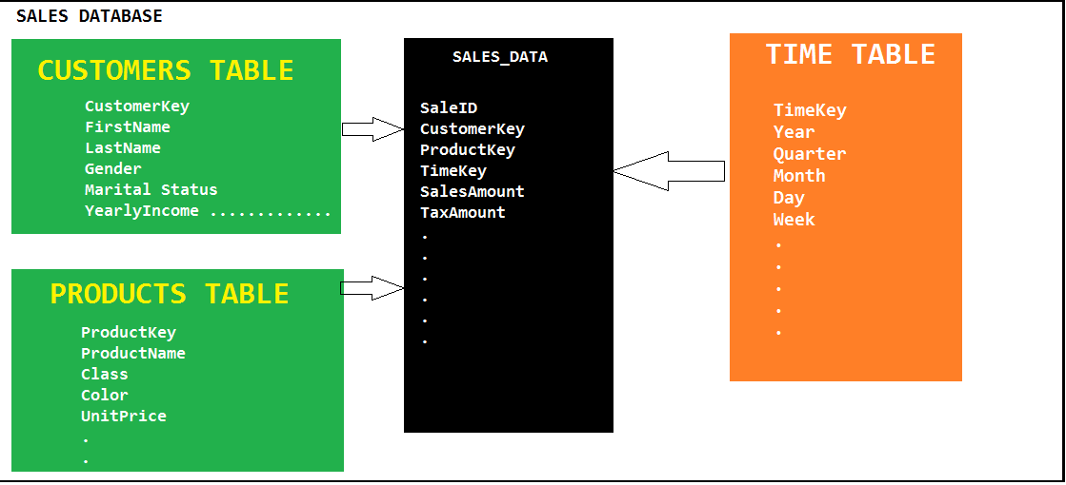

**Plan:**

**Phase 1: We shall design a simplified version of above tables [1 .SQL FILE]**

**Phase 2: We shall install a more detailed version of above tables with data. [4 .SQL FILES]**